Renal Pathophysiology (Objective IIa)
- The following schematic provides a great overview of relevant transporters throughout the nephron.
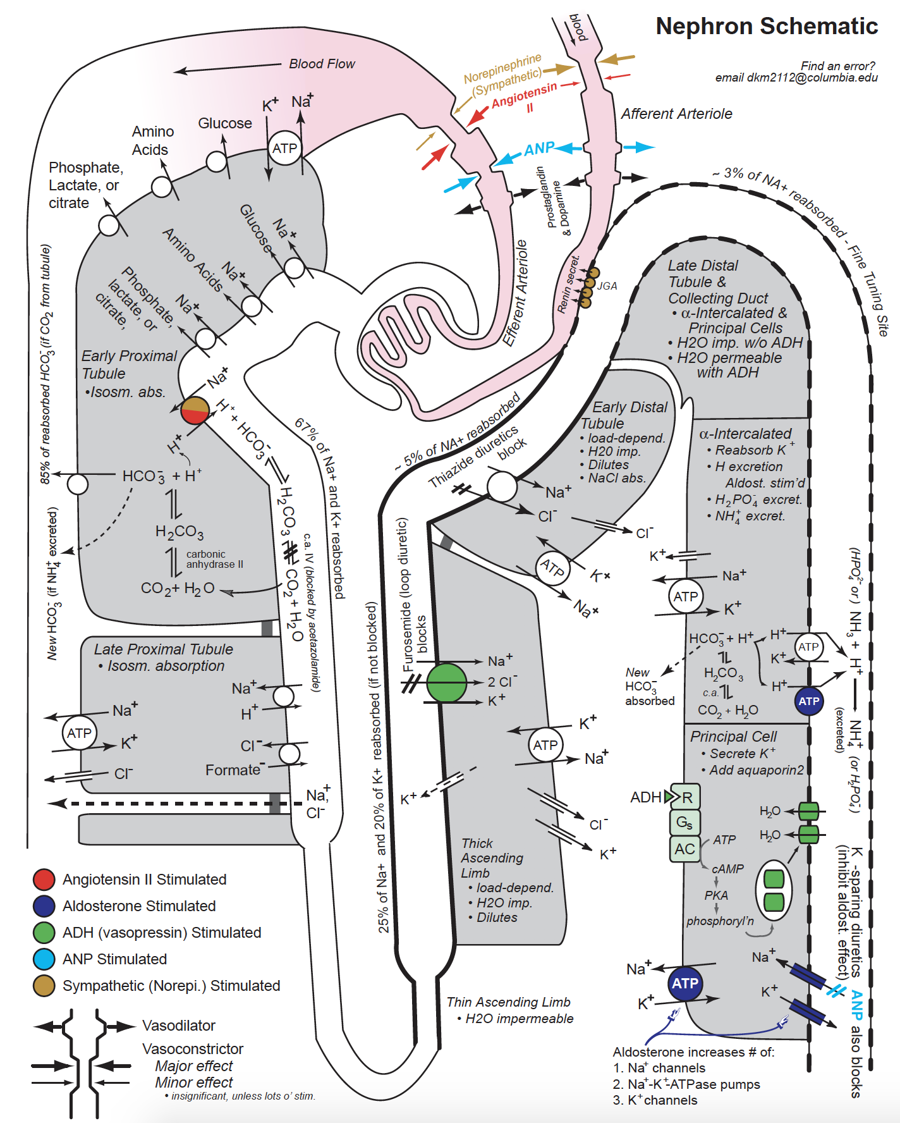
- The neonatal period poses a challenge for management of fluids, electrolytes, and acid-base status especially in premature infants. This review article provides an overview of the rapidly evolving renal system at birth.
- The kidneys play a key role in fluid, electrolytes, and acid-base homeostasis. The following resources provide a great overview of renal pathophysiology as well as the management of pediatric fluid and electrolyte therapy.

