Working with cluster queuing systems
Umass Cluster Variations
Commands are in Red, Output responses are in Blue
For more information, see the cluster queue specific wiki: http://wiki.umassrc.org/wiki/index.php/Main_Page

Supercomputers are actually a collection of many smaller computers loosely tied together, this is why they are often referred to as clusters. When we ssh in to the cluster, we are actually logging in to a specific computer in the cluster called a login node. These computers are designed to communicate from the cluster to the outside world, but they are not designed for doing intensive computation. There are separate computers called compute nodes which are used for running jobs.
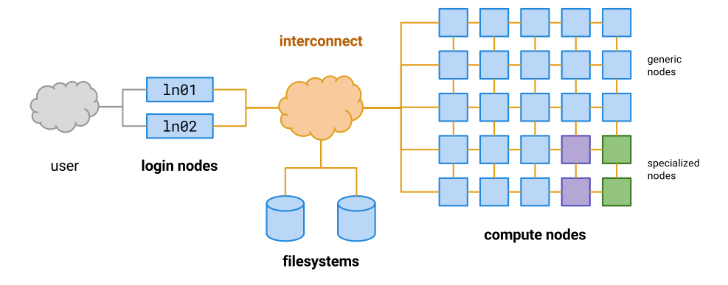
Instead of doing our work directly on the login node, as we have been doing in the previous lessons, we should instead write scripts that contain the commands we want to run, and then use the cluster’s queueing system to allocate those commands to a free computer within the cluster (a compute node).

Let’s test this out by writing a very simple script.
nano test-qsub.sh
Add the following commands to your new script:
hostname
whoami
pwd

This script should print the following information:
- The name of the computer it is running on
- The name of the user that is running it
- The current working directory
Let’s test it out on the login node by asking bash to run it for us:
bash test-qsub.sh
ghpcc06
aw89w
/home/aw89w/chip-tutorial

Hopefully the output should be what you expected. Let’s now submit the script to the cluster and ask it to allocate these commands to a free compute node. We can do this using bsub.

bsub < test-qsub.sh

WARN: No runtime specified. Setting 'bsub -W 1:00' (one hour)
WARN: No queue specified and runtime < 4hrs. Sending to short queue 'bsub -q short'.
WARN: Job does not specify memory required per core. Setting 'bsub -R "rusage[mem=1024]"' (1G per core).
WARN: Job does not specify number of cores. Setting 'bsub -n 1' (single core).
Job <2442052> is submitted to queue <short>.

The way that UMass’ cluster is set up, once the job is finished, we will be emailed with the output. To have the output and errors appear within the cluster as files that we can work with (like the oxford cluster) we will need to add some input cues within our nano script. Let’s return to our nano script.

nano test-qsub.sh
Within the nano script make the following edits:

#BSUB -o test-qsub.log
#BSUB -eo test-qsub.err
hostname
whoami
pwd

#BSUB -o will tell the queue computer to write an output file, which will appear in our directory.
(Note: the queue will run the command within whatever directory you call the command. These were run within my chip-tutorial folder, so the return files were found in my chip-tutorial folder afterwards)
#BSUB -eo will tell the queue computer to write an error file, which will appear in our directory.
If we wanted to specify the path we wanted the queue to use we could include the following command into our nano script:
#BSUB -L (insert path here)

After running our script again with those two #BSUB additions, using ls -l will show that we have 2 additional files.

ls -l /home/aw89w/chip-tutorial/test-qsub.*

-rw-rw-r-- 1 aw89w umw_merav_socolovsky 0 May 21 11:08 test-qsub.err
-rw-rw-r-- 1 aw89w umw_merav_socolovsky 1720 May 21 11:08 test-qsub.log
-rw-rw-r-- 1 aw89w umw_merav_socolovsky 69 May 21 11:07 test-qsub.sh

Ri While our job is running, we can check its status using bjobs:
bjobs
JOBID USER STAT QUEUE FROM_HOST EXEC_HOST JOB_NAME SUBMIT_TIME
2442770 aw89w RUN short ghpcc06 c38b02 *hoami;pwd May 21 11:25

Our cluster will only show us our own jobs running when using bjobs, so a grep function like in Rob’s lesson would not be necessary.
We can add other tags to the beginning of our nano script files for our convenience, these may include:

#BSUB -J job_name (to give our job a job name)
#BSUB -q short (to tell the cluster which queue to use [ long, short, parallel, GPU, interactive]
#BSUB -oo myjob.log (will overwrite an output log file )
#BSUB -oe myjob.err (will overwrite an error log file)

Let’s check our output file:

cat test-qsub.log

c38b09
aw89w
/home/aw89w/chip-tutorial

------------------------------------------------------------
Sender: LSF System <lsfadmin@c38b09>
Subject: Job 2442110: <#BSUB -o test-qsub.log;#BSUB -eo test-qsub.err; hostname;whoami;pwd> in cluster <umghpcc> Done

Job <#BSUB -o test-qsub.log;#BSUB -eo test-qsub.err; hostname;whoami;pwd> was submitted from host <ghpcc06> by user <aw89w> in cluster <umghpcc> at Thu May 21 11:08:15 2020
Job was executed on host(s) <c38b09>, in queue <short>, as user <aw89w> in cluster <umghpcc> at Thu May 21 11:08:15 2020
</home/aw89w> was used as the home directory.
</home/aw89w/chip-tutorial> was used as the working directory.
Started at Thu May 21 11:08:15 2020
Terminated at Thu May 21 11:08:16 2020
Results reported at Thu May 21 11:08:16 2020

Your job looked like:

------------------------------------------------------------
# LSBATCH: User input
#BSUB -o test-qsub.log
#BSUB -eo test-qsub.err

hostname
whoami
pwd

------------------------------------------------------------

Successfully completed.

Resource usage summary:

CPU time : 0.02 sec.
Max Memory : -
Average Memory : -
Total Requested Memory : 1024.00 MB
Delta Memory : -
Max Swap : -
Max Processes : -
Max Threads : -
Run time : 9 sec.
Turnaround time : 1 sec.

The output (if any) is above this job summary.

PS:

Read file <test-qsub.err> for stderr output of this job.

